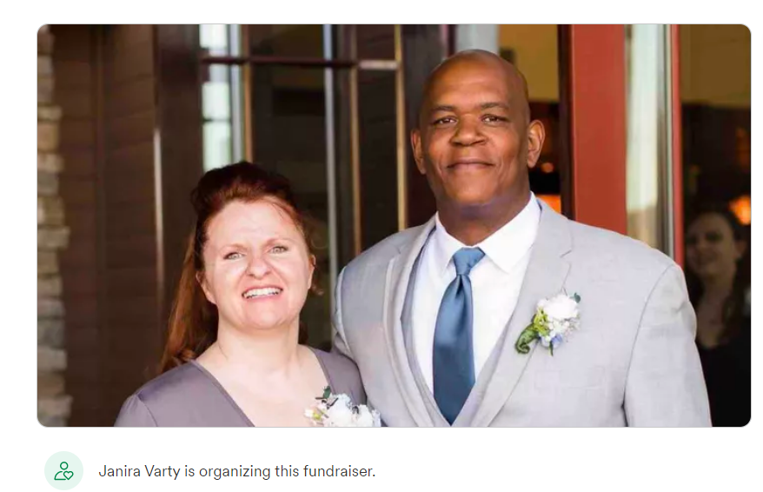
It is with great sadness that I share the news of the unexpected passing of Detective Damon Earl at his home this morning (11/28). Damon had been with the Investigation Division since 2017, serving in the Major Crimes Unit and later the TriNET narcotics task force. Damon was also one of the Investigation Division’s certified polygraph examiners. Prior to coming to the Investigation Division, Damon served at the Division of Parole and Probation and the Sparks Police Department.

Damon was thoughtful, had a great sense of humor, and loved being a law enforcement officer. He often spoke about his family, especially his granddaughter, and the joy they brought to his life and how proud he was of them.
Damon was loved by his coworkers, and he will be truly missed. Please keep his family in your thoughts during this difficult time. As information about potential services becomes available, I will pass that information along. Thank you.

Respectfully,

Ryan Miller, Chief
Nevada State Police
Investigation Division

